NAME: VIVIAN KERUBO MOSOMI

Email: [kerubomosmi7@gmail.com](mailto:kerubomosmi7@gmail.com)

Country: Kenya

College: Jomo Kenyatta University of Agriculture and Technology (JKUAT)

Specialization: Data Science

**Problem Description**

ABC Bank wants to predict whether a particular customer will buy their term deposit product based on their past interactions with the bank or other financial institutions. This will allow the bank to focus its marketing efforts on customers who are more likely to purchase the product.

**GitHub Repository Link**

https://github.com/Vee2002/DataGlacier_Internship/tree/vc/Data%20Glacier

**EDA Performed on the Data**

**1.Univariate Analysis**

1. Purchased deposit counts

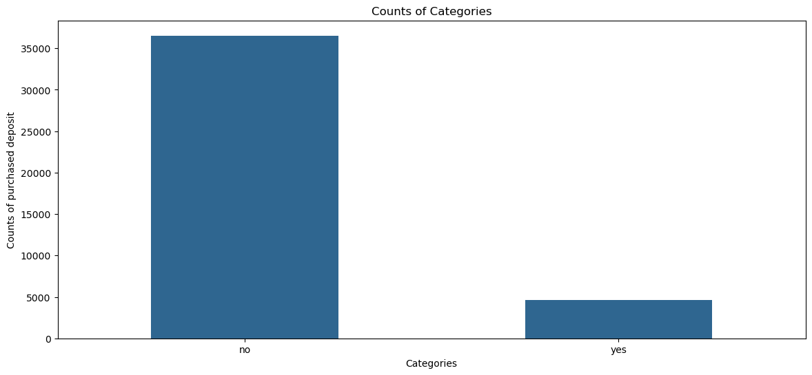

Most people did not purchase the term deposit.

1. Job Categories

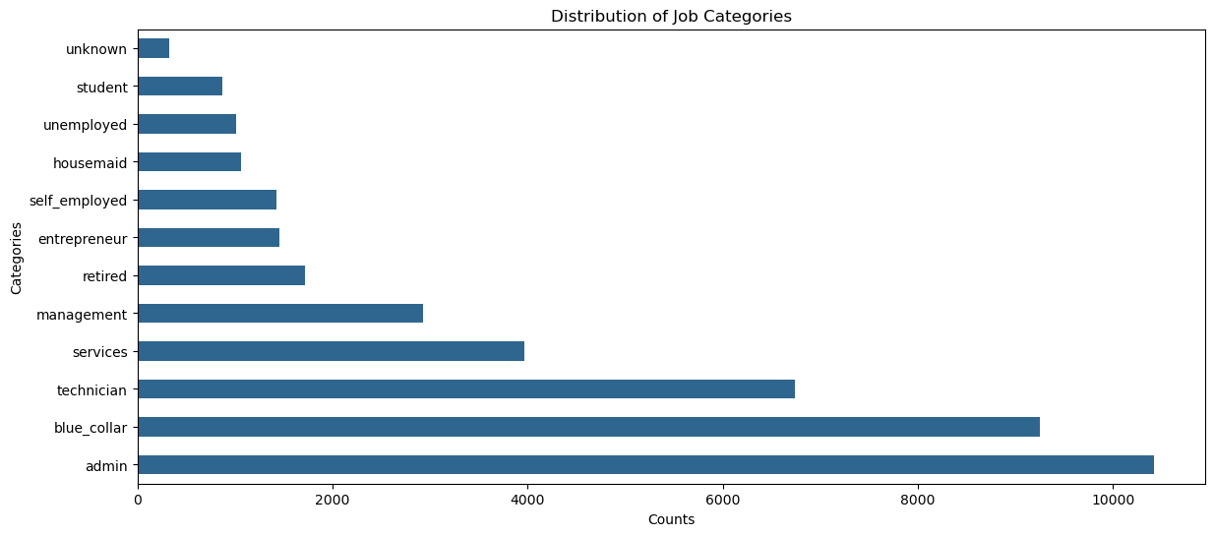

Most people work as admins, followed by blue collar jobs and technicians.

1. Marital Categories

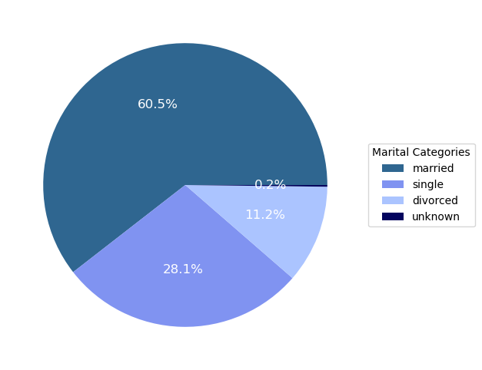

Most customers are married as they lead by 60.5%.Single people follow by 28.1%, and divorced are 11.2%.

1. Education Categories

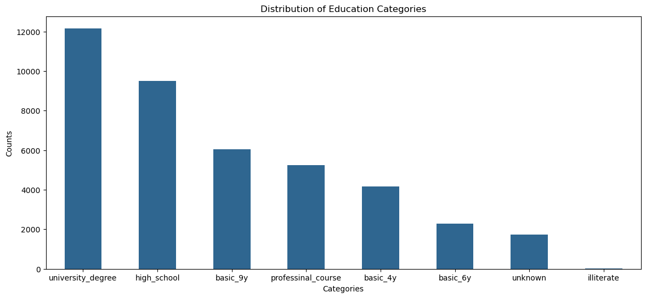

` Most people are at the level of university degree followed by high school.

1. Default Loans

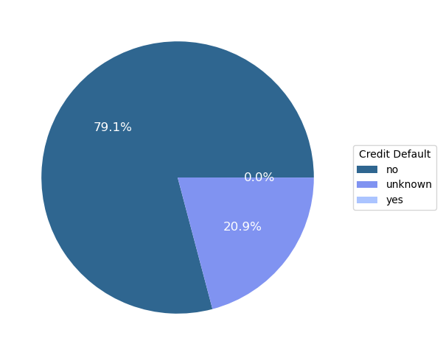

From the chart most people do not have credit defaults

1. Housing Loan

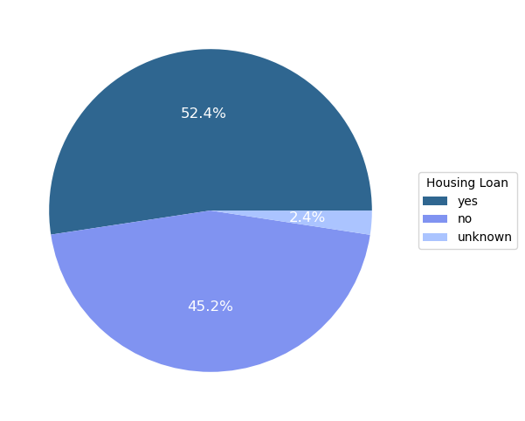

Most people have housing loans cause of the higher percentage of 52.4%

1. Personal Loans

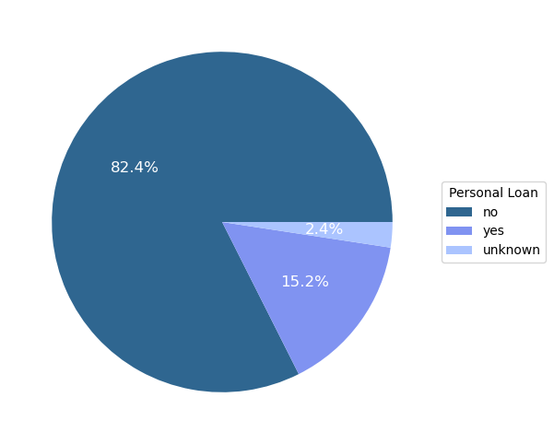

Most customers do not have personal loans

1. Contact Categories

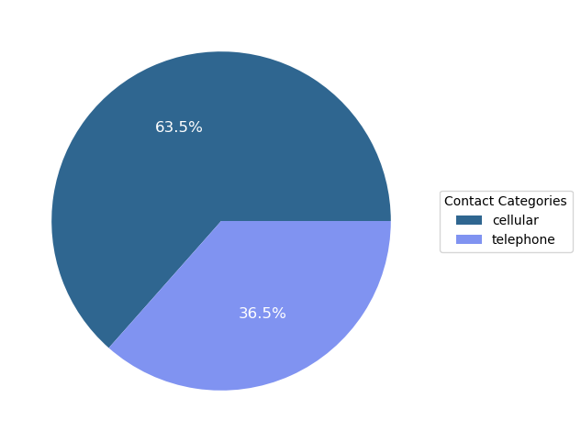

The contact is done to most customers via cellular not telephone.

1. Outcome of previous marketing campaign distribution

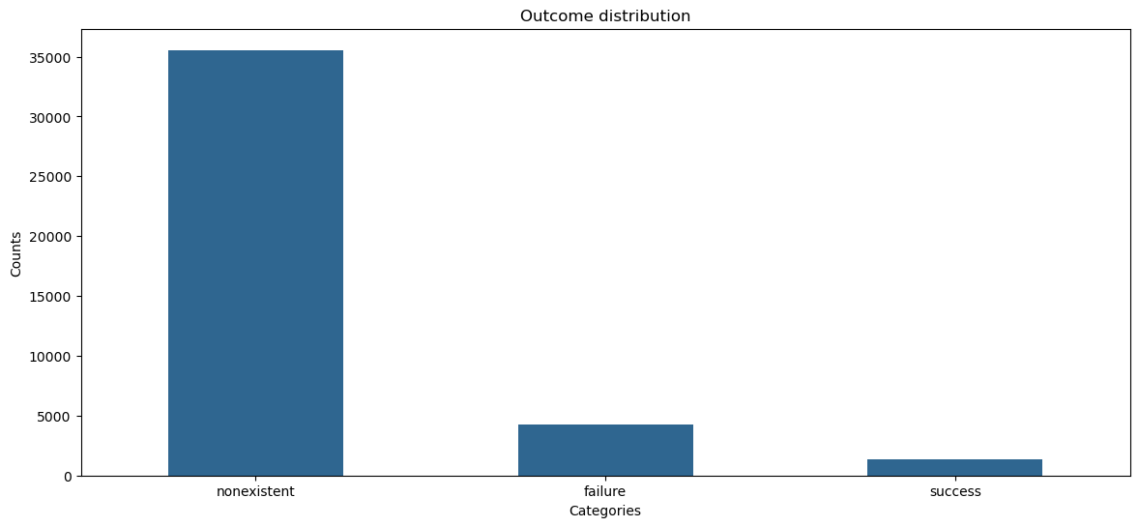

The above plot is communicating that most customers were not contacted during the previous marketing campaign and the failure was higher than the success.

**2.Bivariate Analysis**

i) Job by purchased deposit

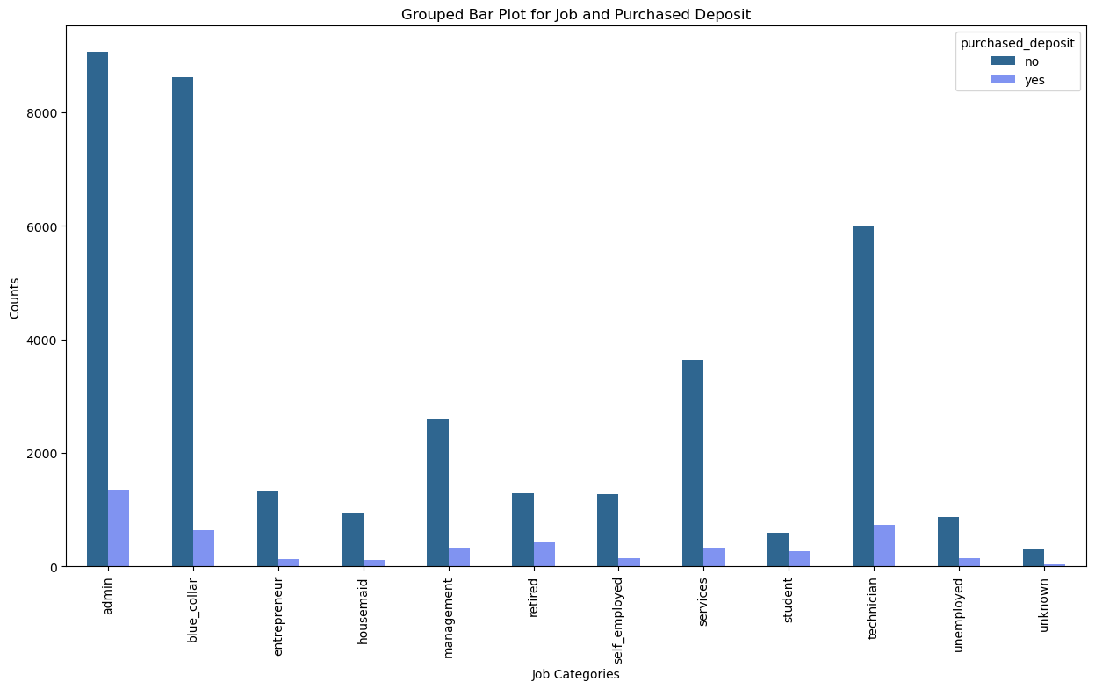

Most customers in their respective job categories did not purchase the term deposit.

ii) Education by purchased deposit

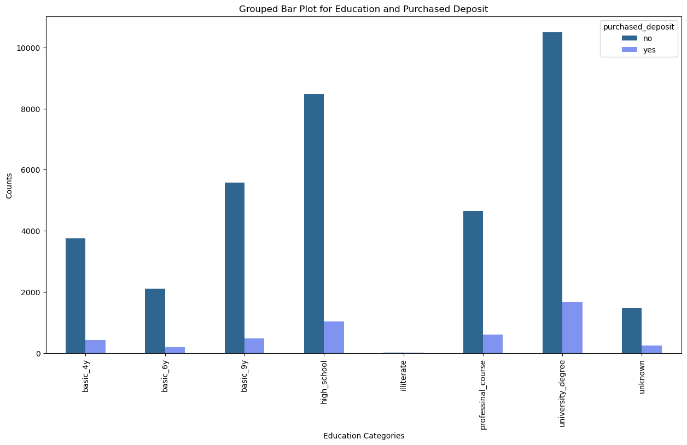

The conclusion from the above plot is also that most people did not purchase the term deposit in all education levels. But those at the university degree level purchased more compared to others.

iii) Marital by purchased deposit

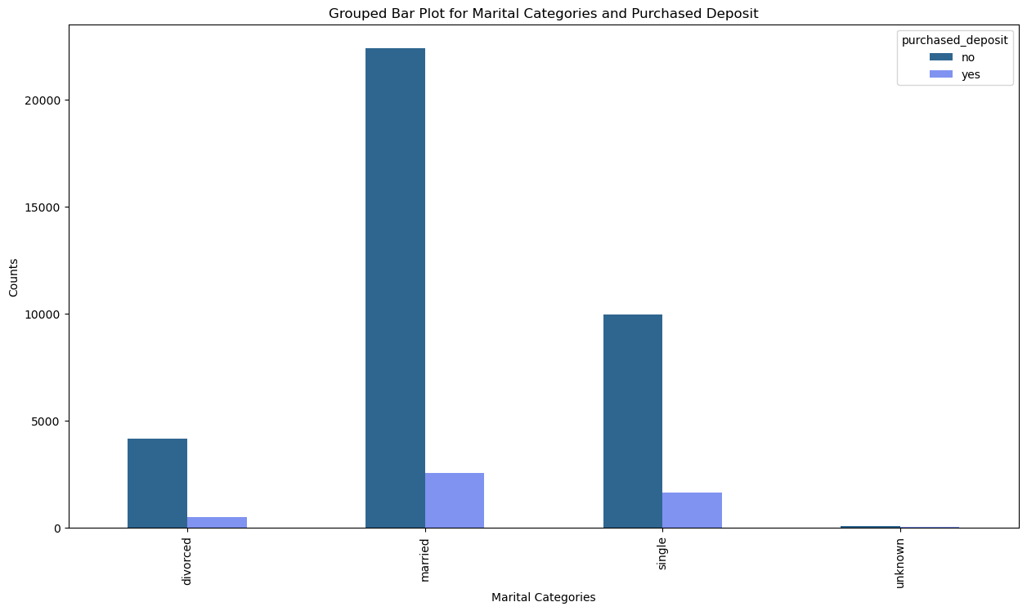

For marital categories, most customers also did not purchase the term deposit. But the leading group is the married one.

iv) Credit defaulters and purchased deposit

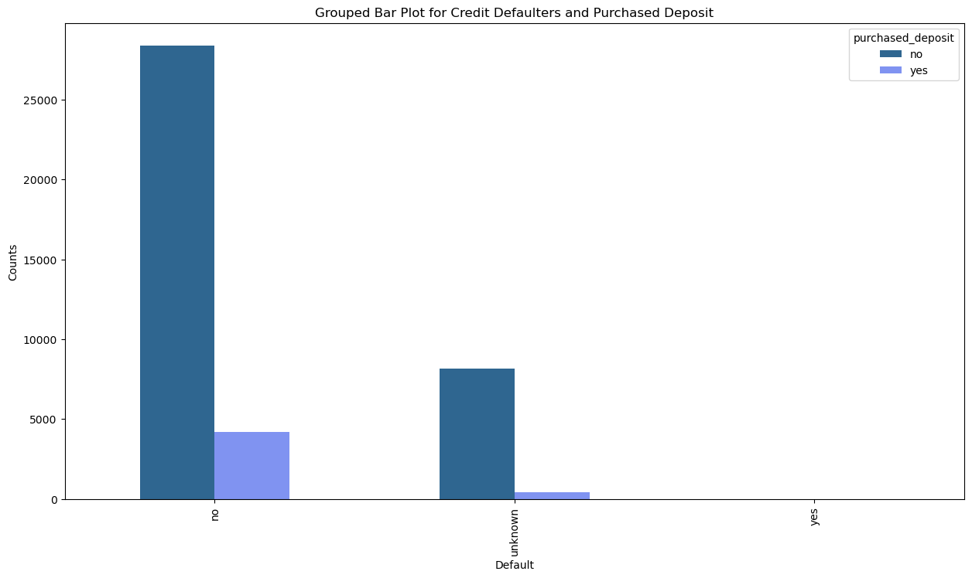

Most people who do not have credit defaults did not purchase the term deposit.

v) Housing by purchased deposit

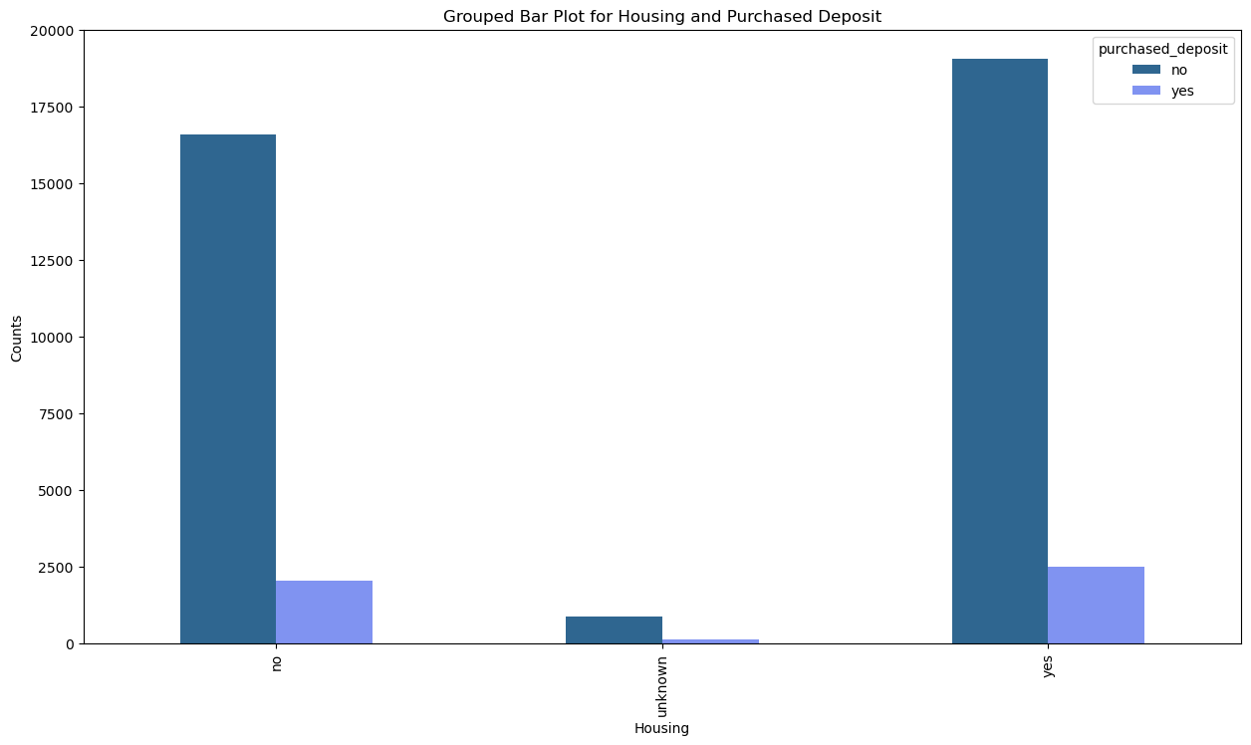

People with housing loans purchases the term deposits more.

vi) Loan by purchased deposit

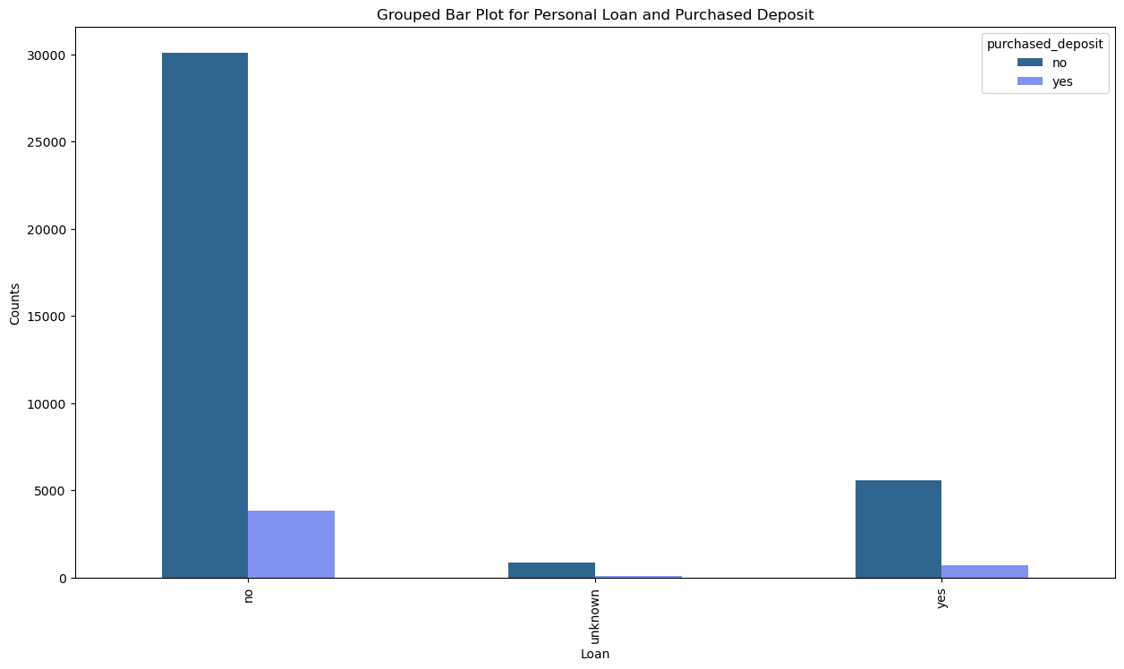

Most customers who do not have loans did not purchase the term deposit

vii) Contact by purchased deposit.

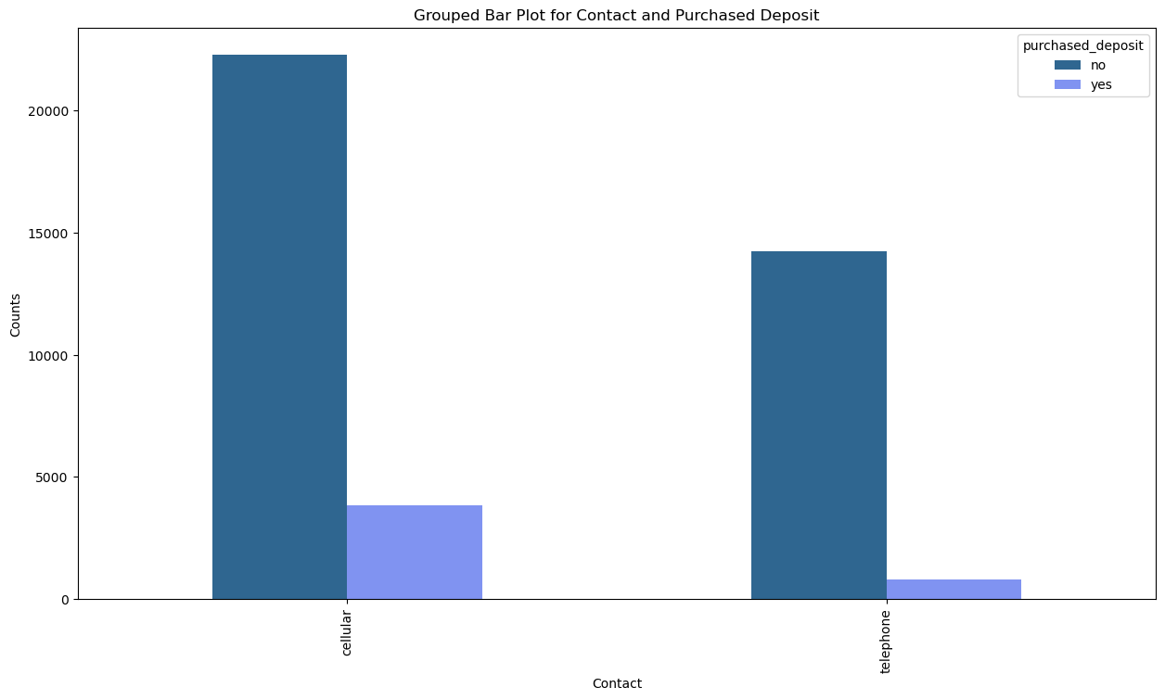

Most of the customers who were contacted by cellular and telephone did not purchase the term deposits but those who were contacted through cellular purchased the term deposit a bit more compared to those contacted through telephone

viii) Previous outcome of the campaign by purchased deposit

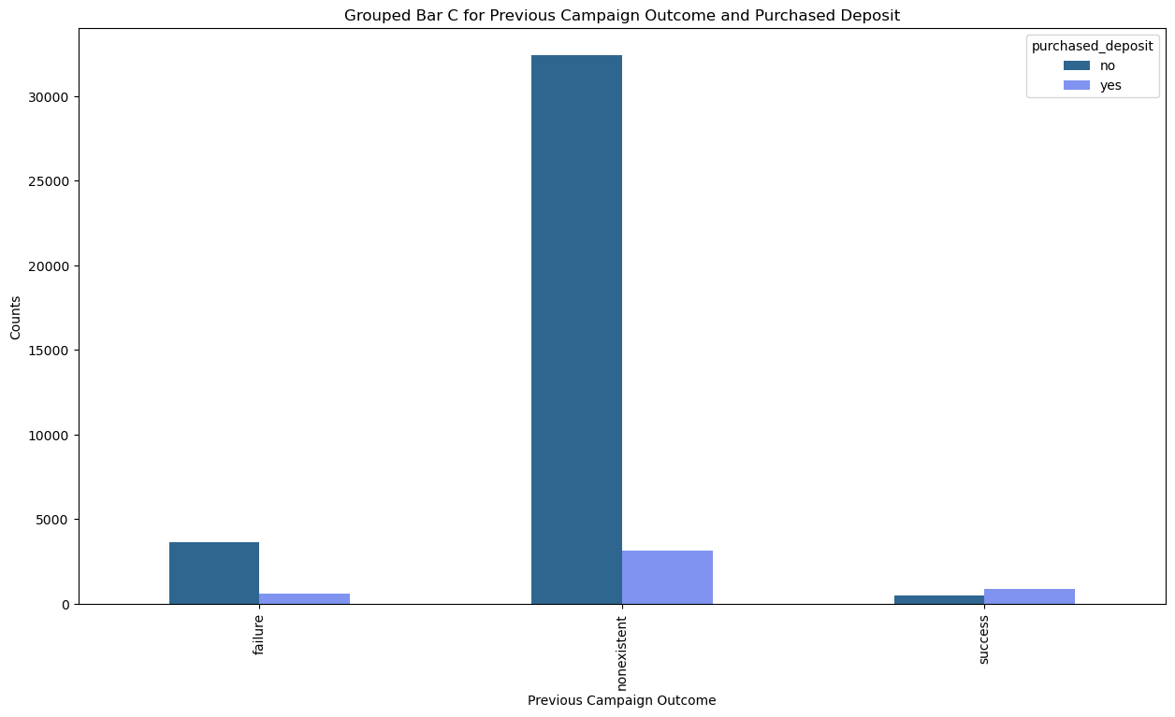

Many people were not contacted during the previous marketing campaign.

ix) Month by purchased deposit

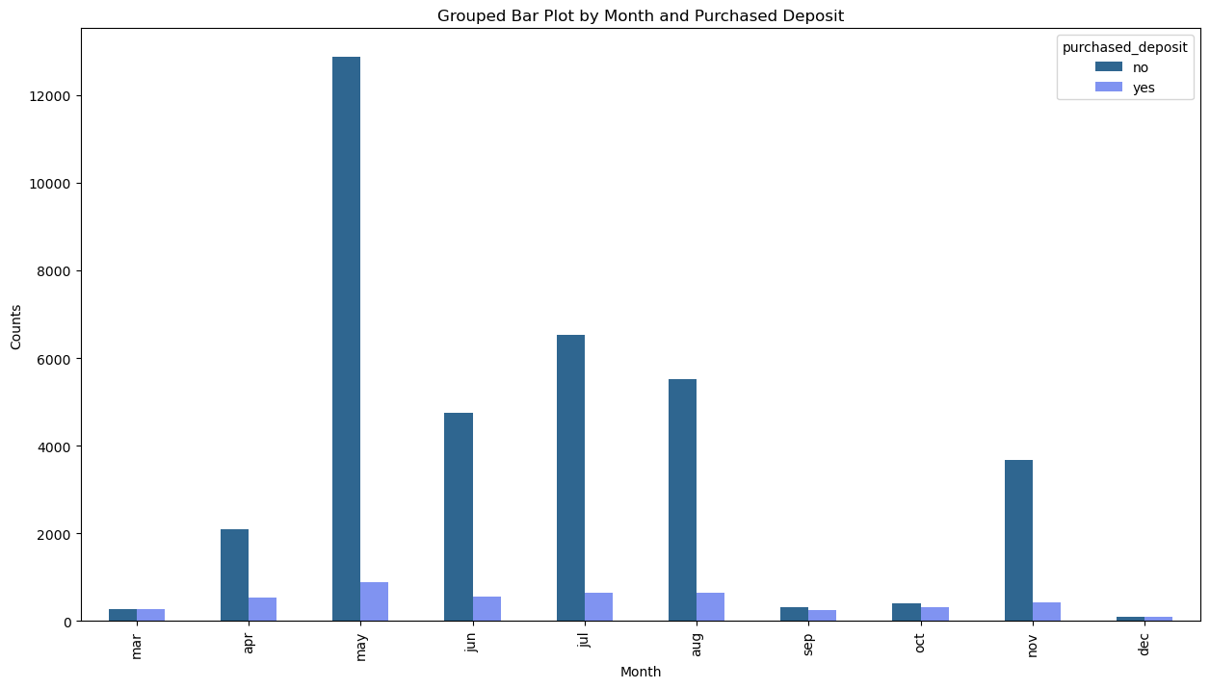

Most customers did not purchase term deposits regardless of the month but the months May, June, July, August (Mid-Year), the purchase was better

x) Distribution of call duration

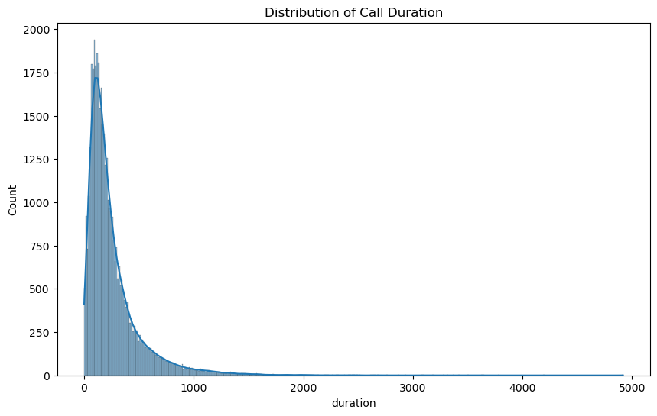

Observation is that the duration for most calls to customers approximately ranges between 0 to 500 seconds.

xi) Consumer price index by month

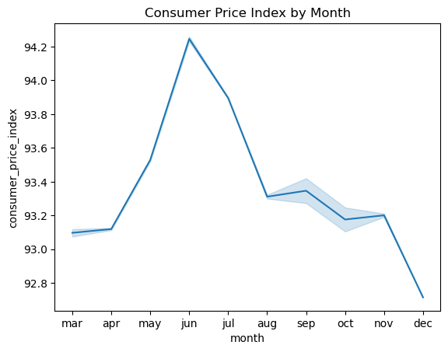

The above line plot shows that inflation is highest Mid-Year.

xii) Euribor Rate by Month

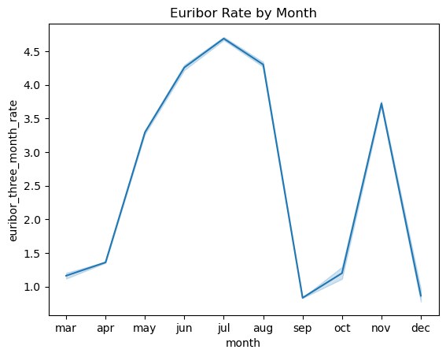

The Euribor rate is high mid-year and November

xiii) Consumer Confidence Index by Month

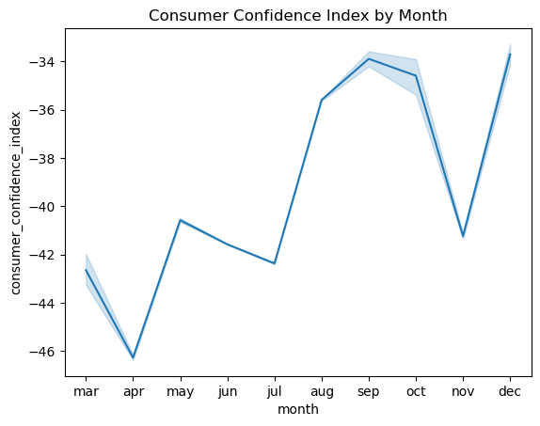

The plot shows a fluctuating trend on the consumer confidence index by months

xiv) Number of Employees by month

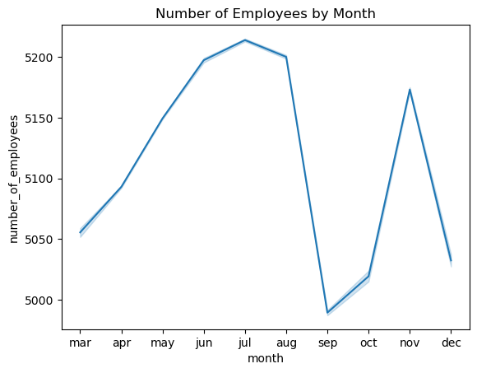

According to the plot, the number of employees is on the rise from March to August

**3. Multivariate Analysis**

i) Correlation between Employee Variation Rate and Term Deposit Purchase

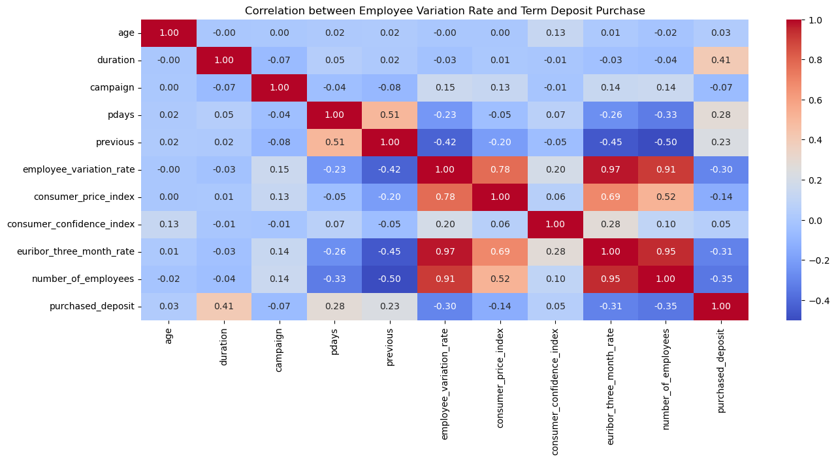

Duration is moderately positively correlated to purchased deposit. It has a positive correlation of 0.41

Pdays and previous are weakly positively related to purchased deposits. With a correlation of 0.28 and 0.23 respectively.

Age has a very weak positive correlation of 0.03 to purchased deposit.

The following columns are negatively correlated to purchased deposit:

campaign, employee_variation_rate, consumer_price_index, euribor_three_month_rate, number_of_employees

**Recommendations**

1.Develop marketing campaigns that highlight the benefits of term deposits, such as security, returns, and suitability for long-term goals by promotions or incentives eg slightly higher interests for higher customers. The bank can consider holding webinars and workshops to educate customers on the importance of term deposits.

2.Increase the reach and frequency of marketing campaigns, particularly focusing on customers who were not contacted previously. By considering using cellular to contact customers as it is yielding more results compared to telephone.

3.Focus marketing efforts during periods of high consumer confidence or low inflation (e.g., early in the year or after mid-year). The bank can monitor economic indicators like the Consumer Confidence Index and Euribor rates to plan campaigns strategically.

4.Train agents to have meaningful, informative conversations that address customer concerns within the call duration 0-500 seconds as most calls are within that range. They can provide training to call agents on how to effectively pitch term deposits.

5.Increase follow-ups for customers contacted in recent campaigns to improve conversion rates.